NBER

2014 Martin S. Feldstein Lecture

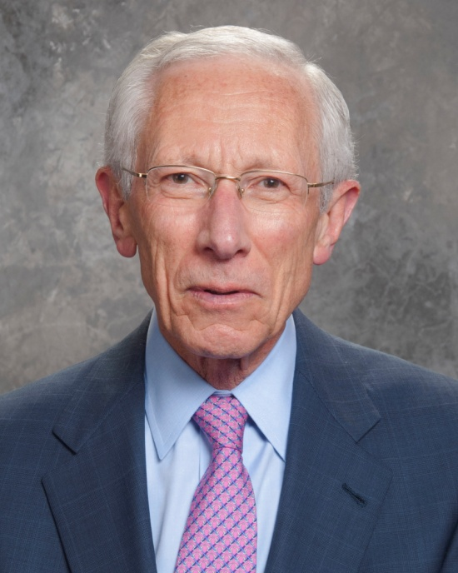

Stanley Fischer
Vice Chair of the Federal Reserve System
Financial Reform: Where Do We Stand?

Royal Sonesta Hotel – Ballroom B
July 10, 2014, 4:30 pm - 5:30 pm
Reception to follow from 5:30 pm to 6:15 pm

